Ai assisted coding Assignment-21.5
Name:E.Srivarsha
Batch-44
HTNO:2303a52343
Task A – AI-Based Initial Program Development
Prompt: 1. Generate a simple Python program to calculate student grades based on marks.
2. Improve the student grade calculator by adding input validation, error handling, and better user interaction.
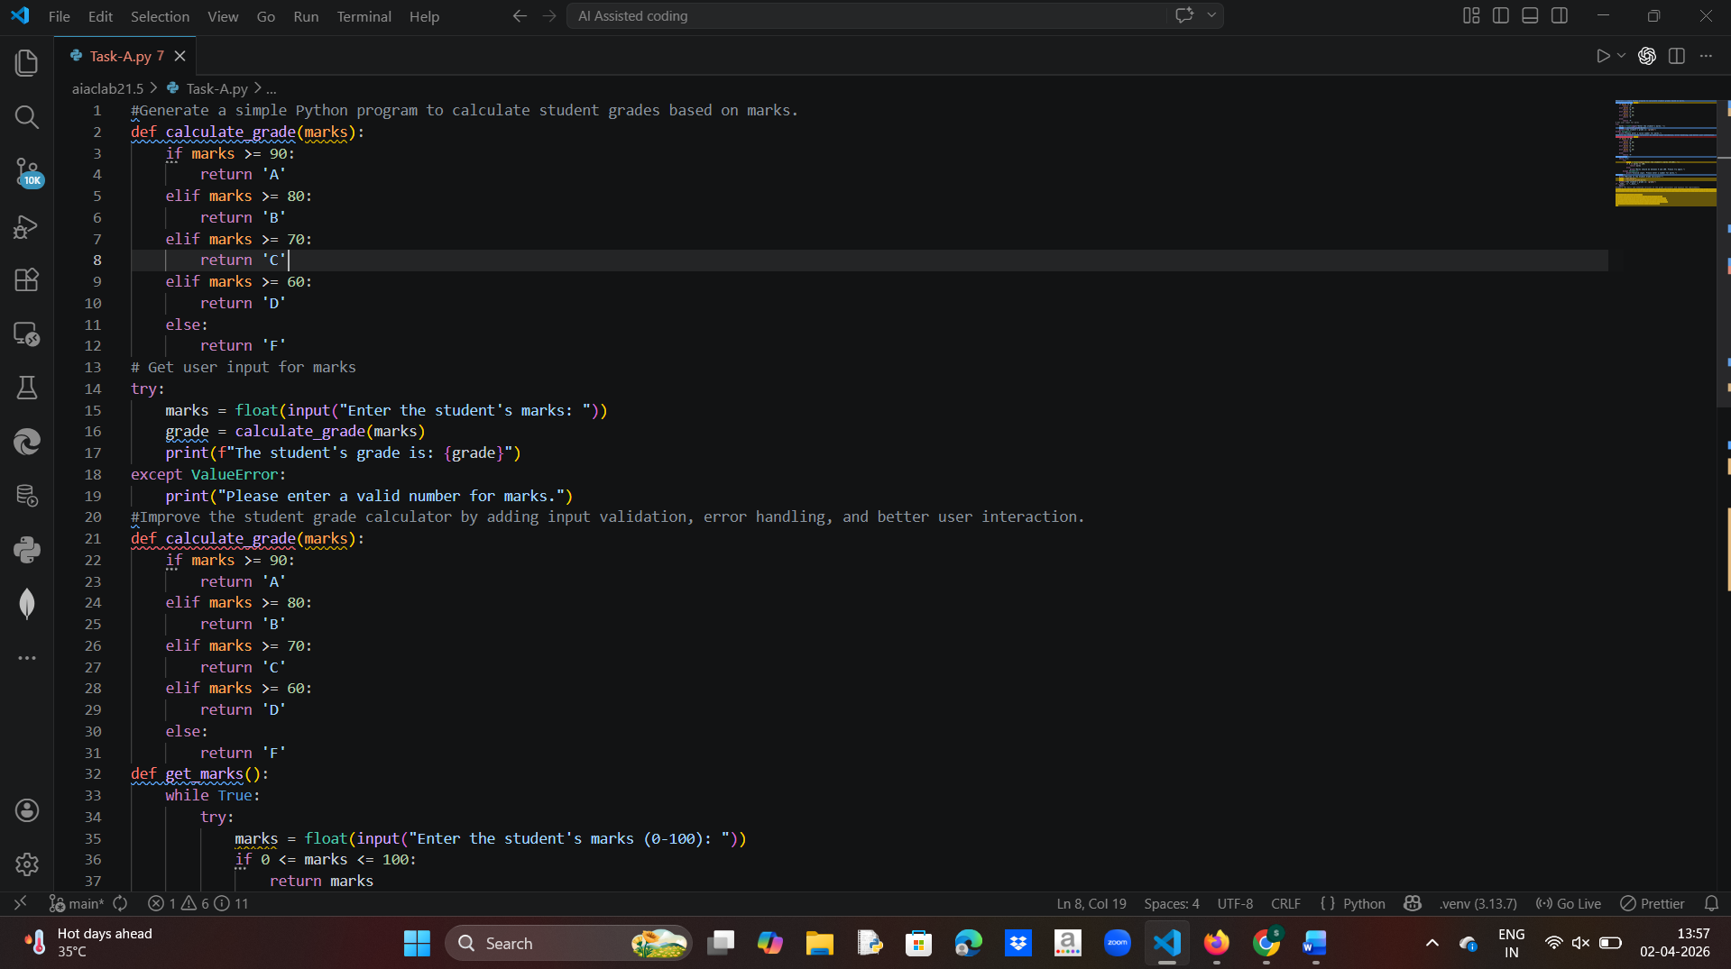
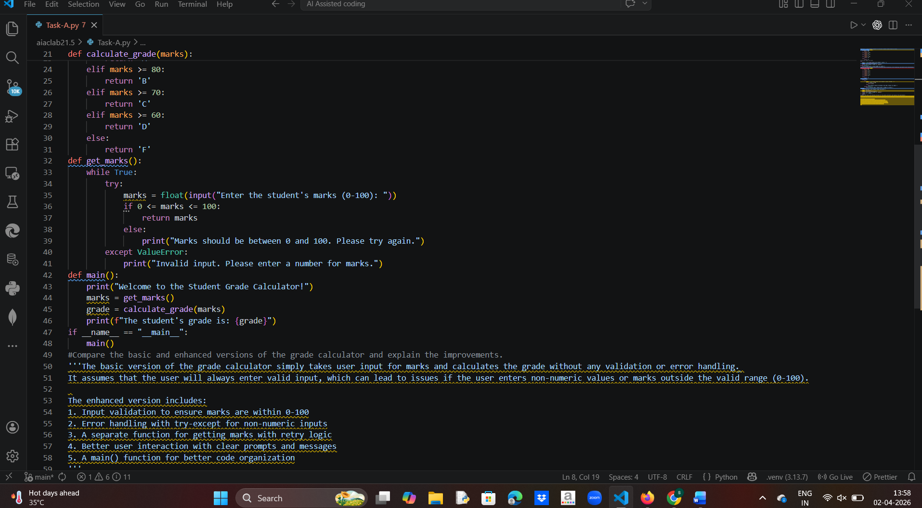
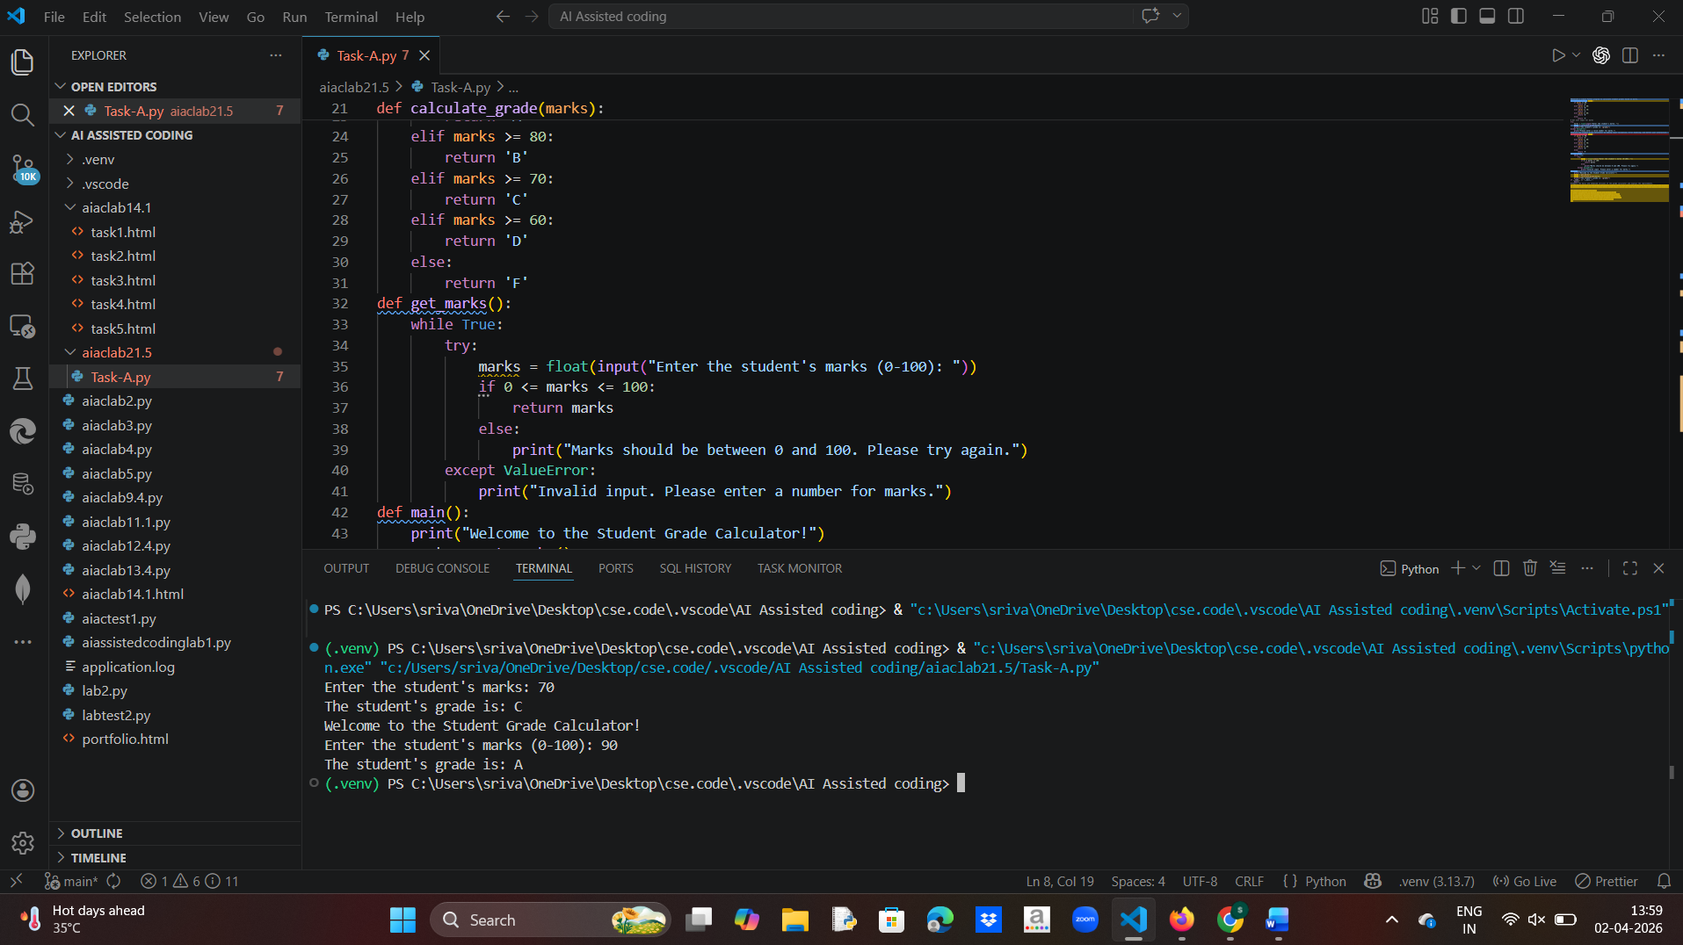
The basic version of the grade calculator simply takes user input for marks and calculates the grade without any validation or error handling.
It assumes that the user will always enter valid input, which can lead to issues if the user enters non-numeric values or marks outside the valid range (0-100).

The enhanced version includes:
1. Input validation to ensure marks are within 0-100
2. Error handling with try-except for non-numeric inputs
3. A separate function for getting marks with retry logic
4. Better user interaction with clear prompts and messages
5. A main() function for better code organization
Task B – AI-Assisted Application Improvement
Prompt: 1.Generate a simple Python program for a basic library management system.
2. Enhance the library management system by adding features like search, display, and better data structure.
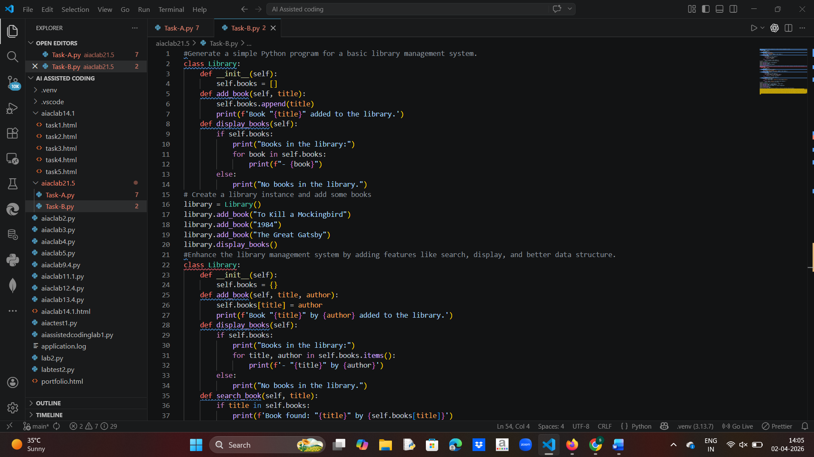
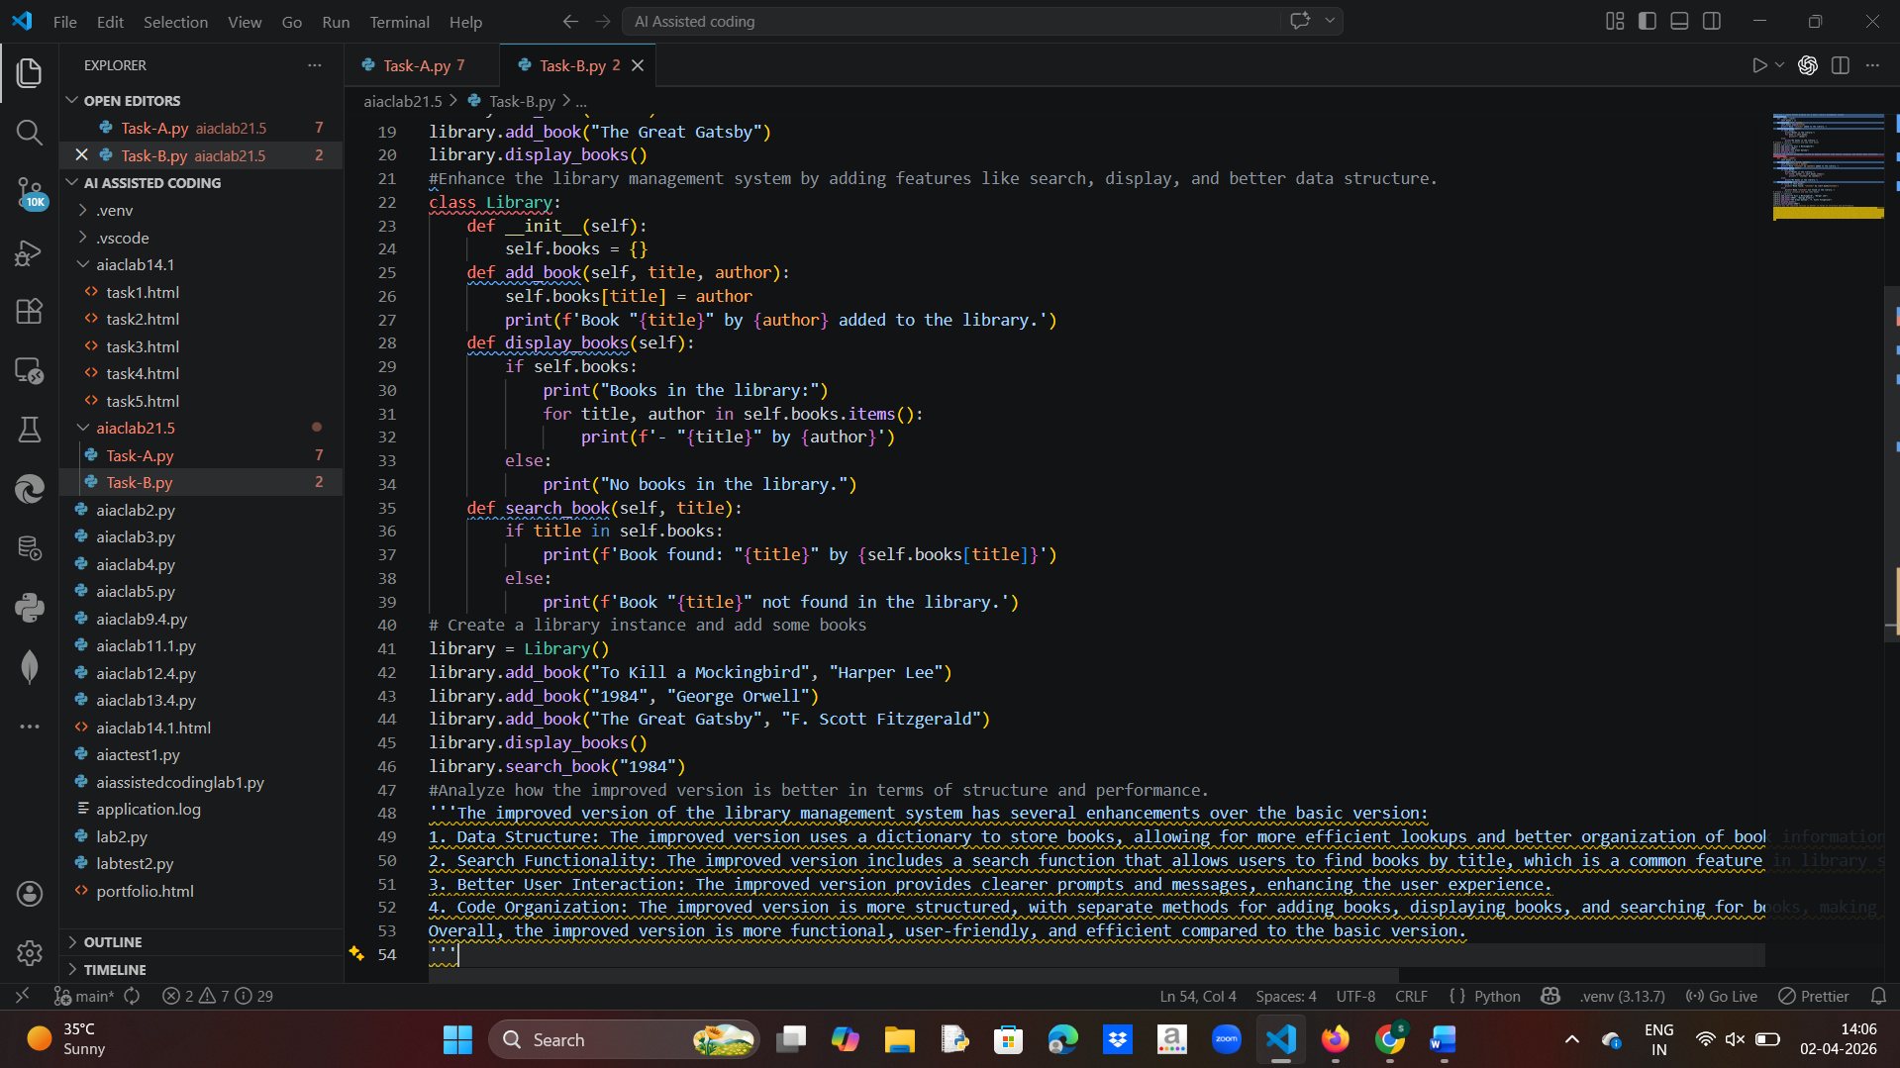
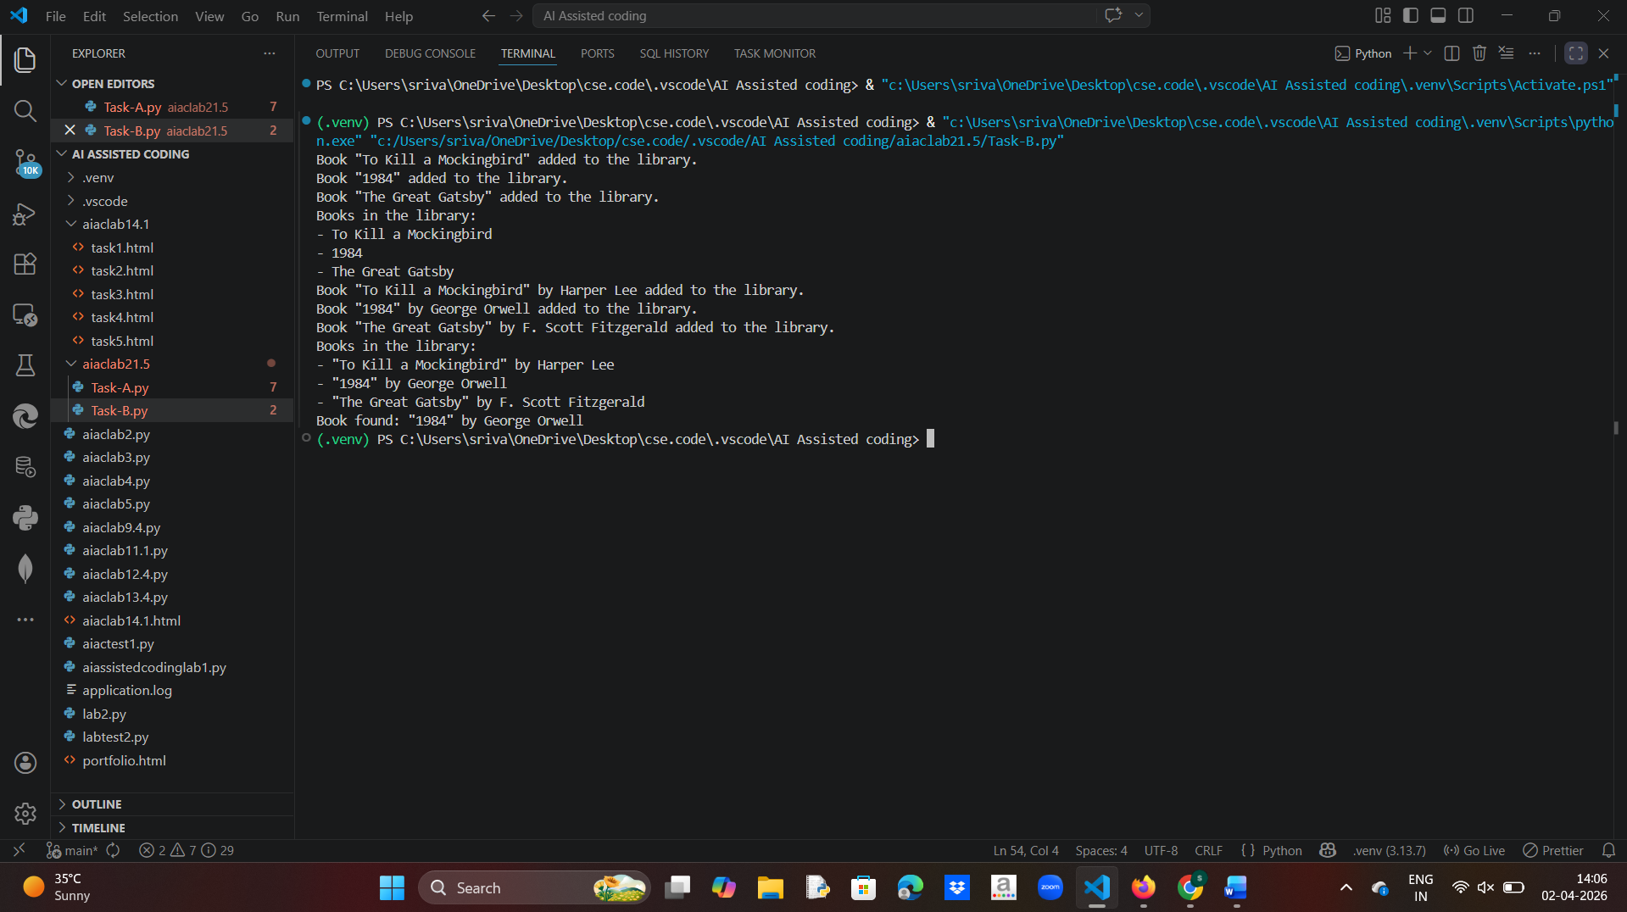
3. Improvements
- Structured data (dictionary)
- Search functionality
- Better scalability
Task C – Git Workflow Practice
Prompt: Provide step-by-step Git commands to initialize a repository, create a branch, commit changes, and merge them into the main branch.
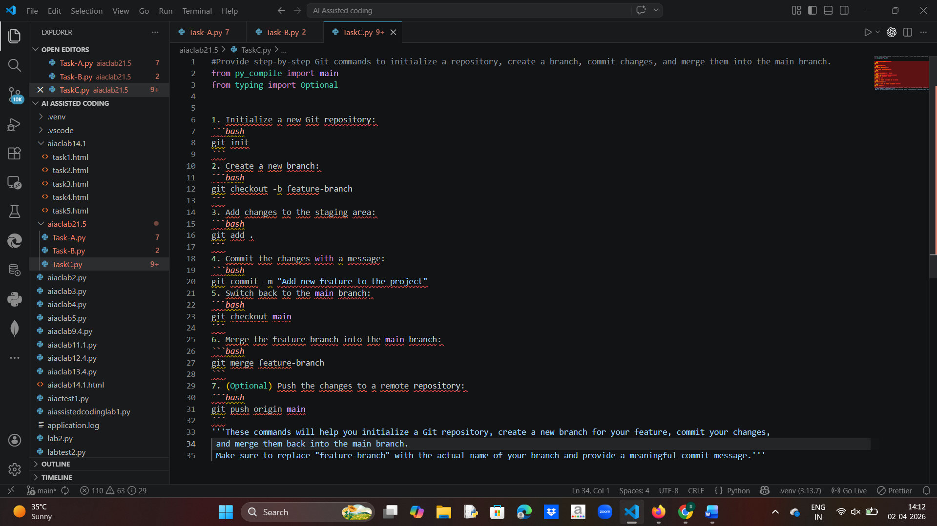
Task D – Branching and Merging with AI Support
Prompt:
Explain how to create a feature branch, modify code using AI suggestions, and merge it back into the main branch with proper verification.
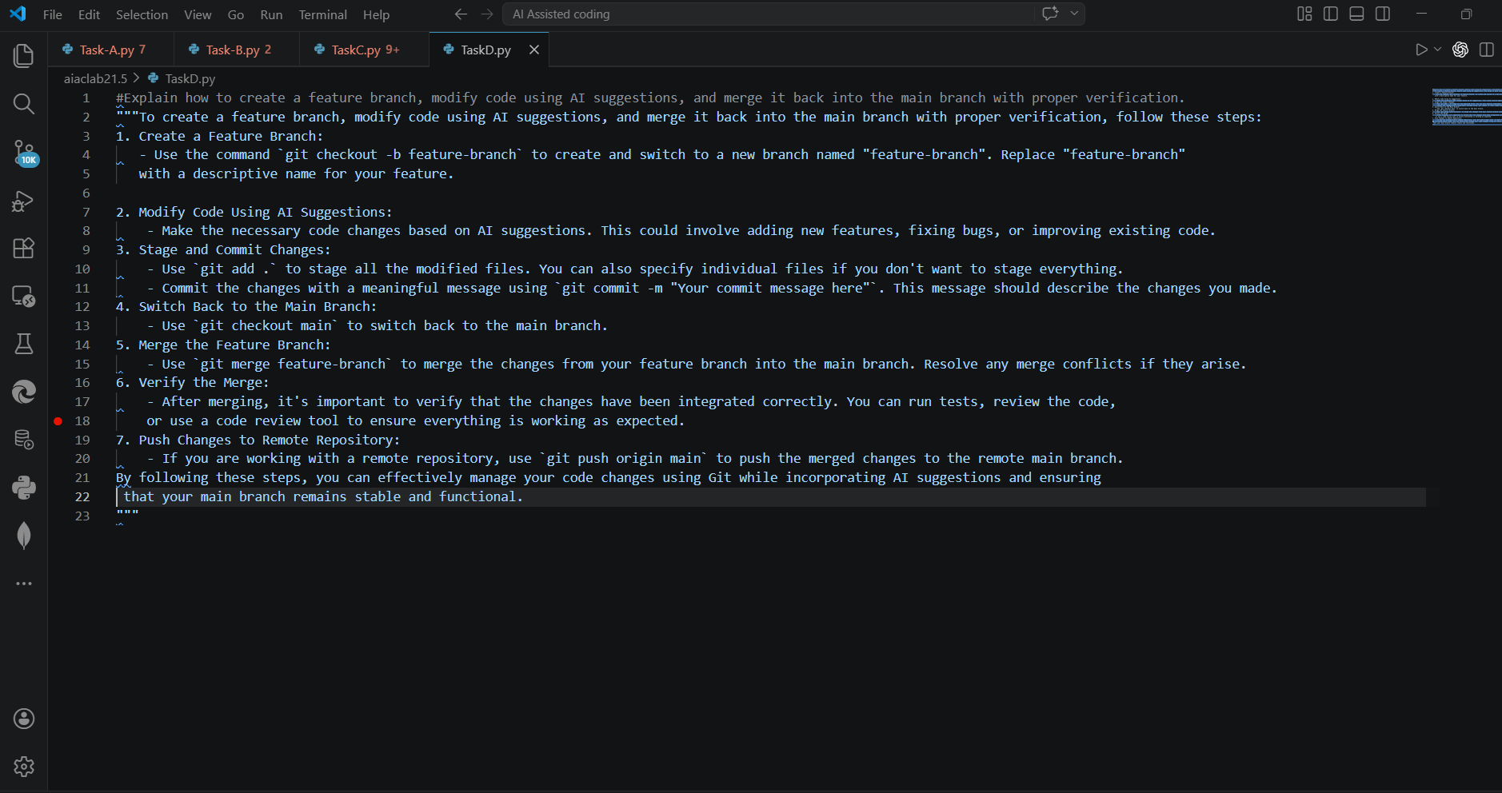
Task E – AI for Commit Message Writing
Prompt:
Generate professional Git commit messages for multiple code changes and compare them with simple/manual commit messages.
